**Name: Kartikeya Narian Khanna**

**SAP ID: 50078285**

**Roll No: R171219049**

**Course: B.Tech CSE Devops**

**Batch: 2**

**Build and Release Management Lab-1**

**Aim :** 1. Create a java project using Maven

2. Run the following goals on this project • Clean • Compile • Install

3. Adding external jar file

**FOR CLEAN:**

Step 1: Right click the project name -> Run as -> Maven Build…

Step 2: In the goals section, write clean and click on “Run”

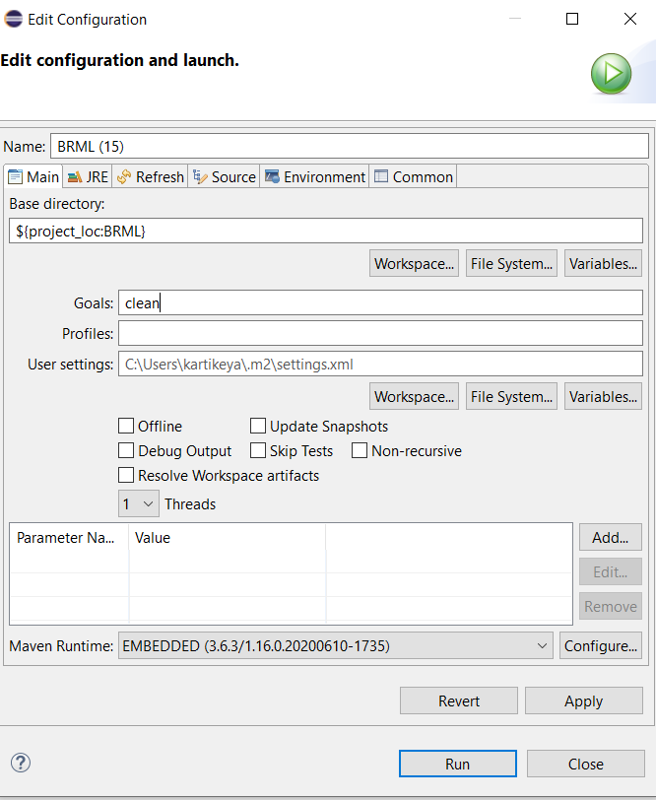

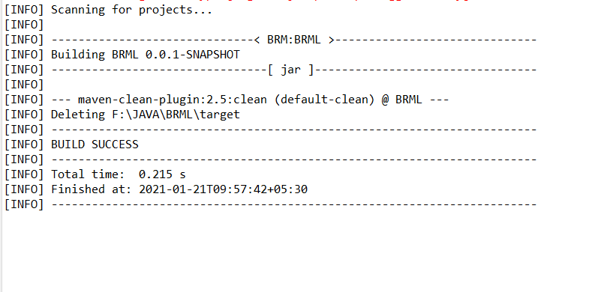

**FOR COMPILE:**

Step 1: Right click the project name -> Run as -> Maven Build…

Step 2: In the goals section, write compile and click on “Run”

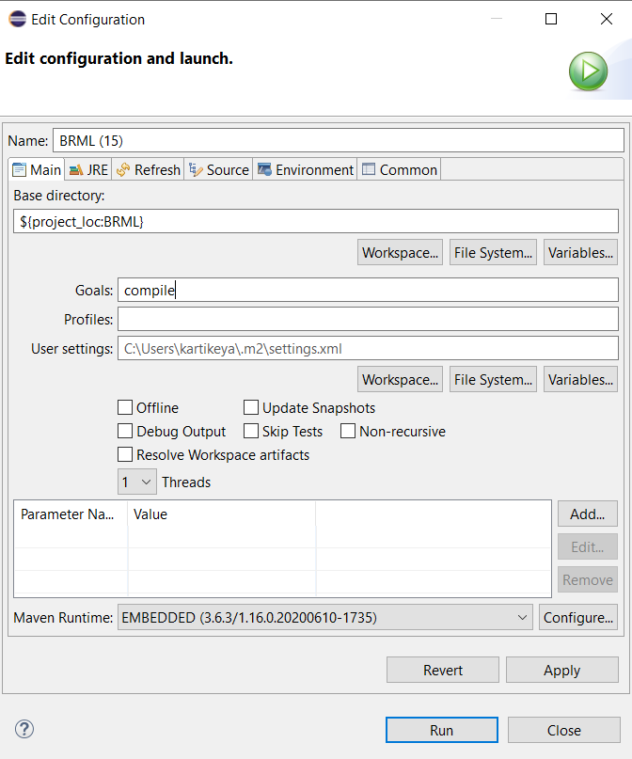

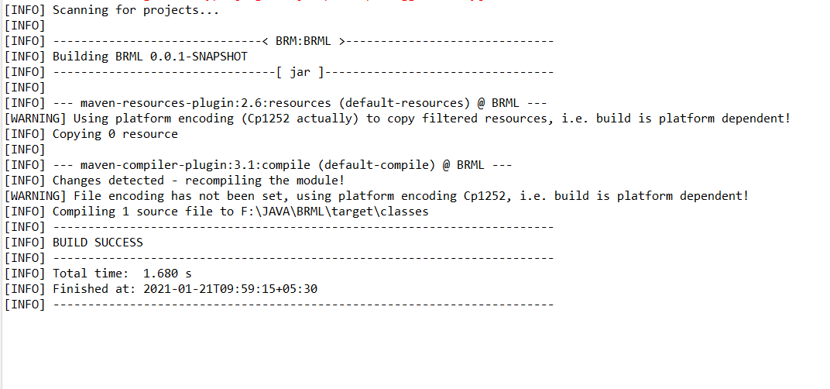

**FOR INSTALL:**

Step 1: Right click the project name -> Run as -> Maven Build…

Step 2: In the goals section, write install and click on “Run”

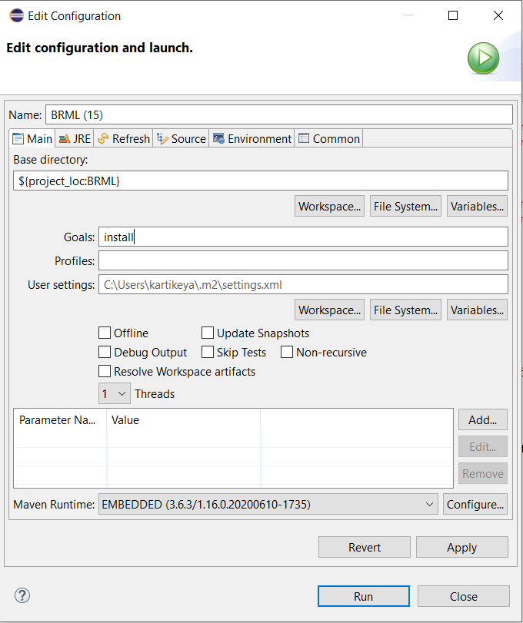

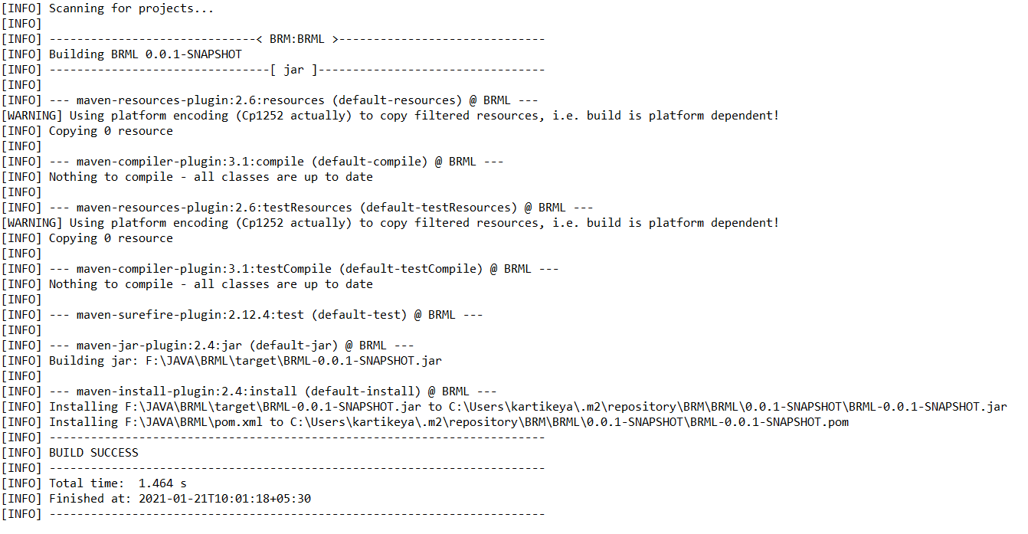

**Adding external .jar file to existing java file**

